1. “Implicit Grant Type” is less secure as compared to “Authorization Grant Type”.
2. 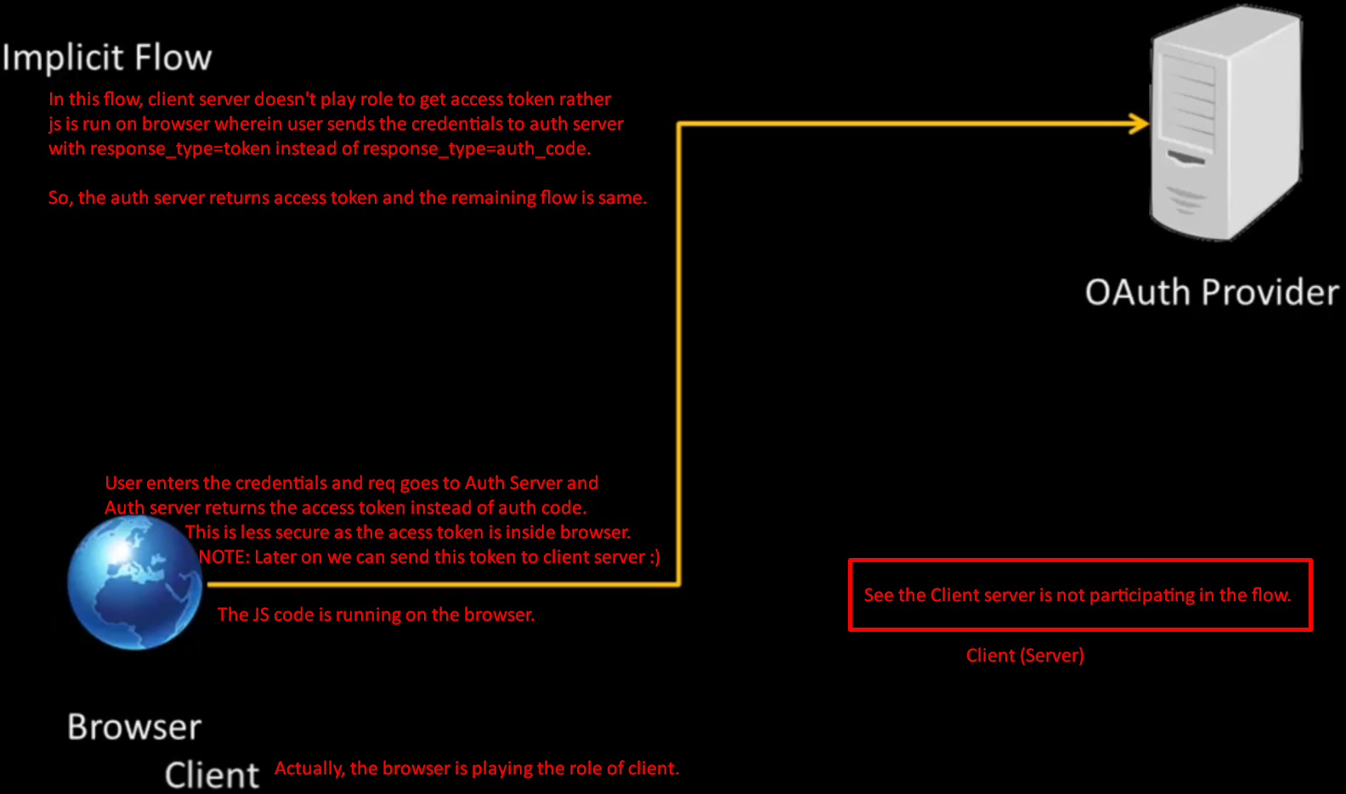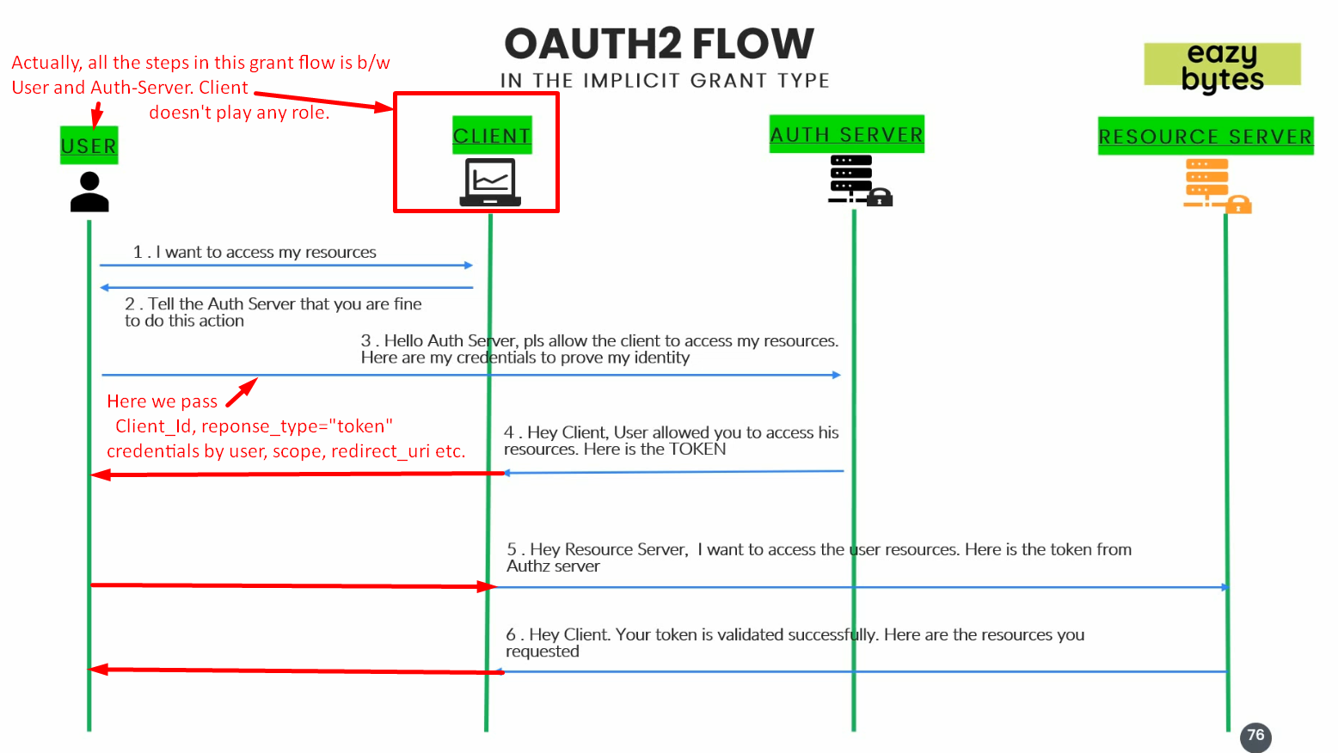
3. 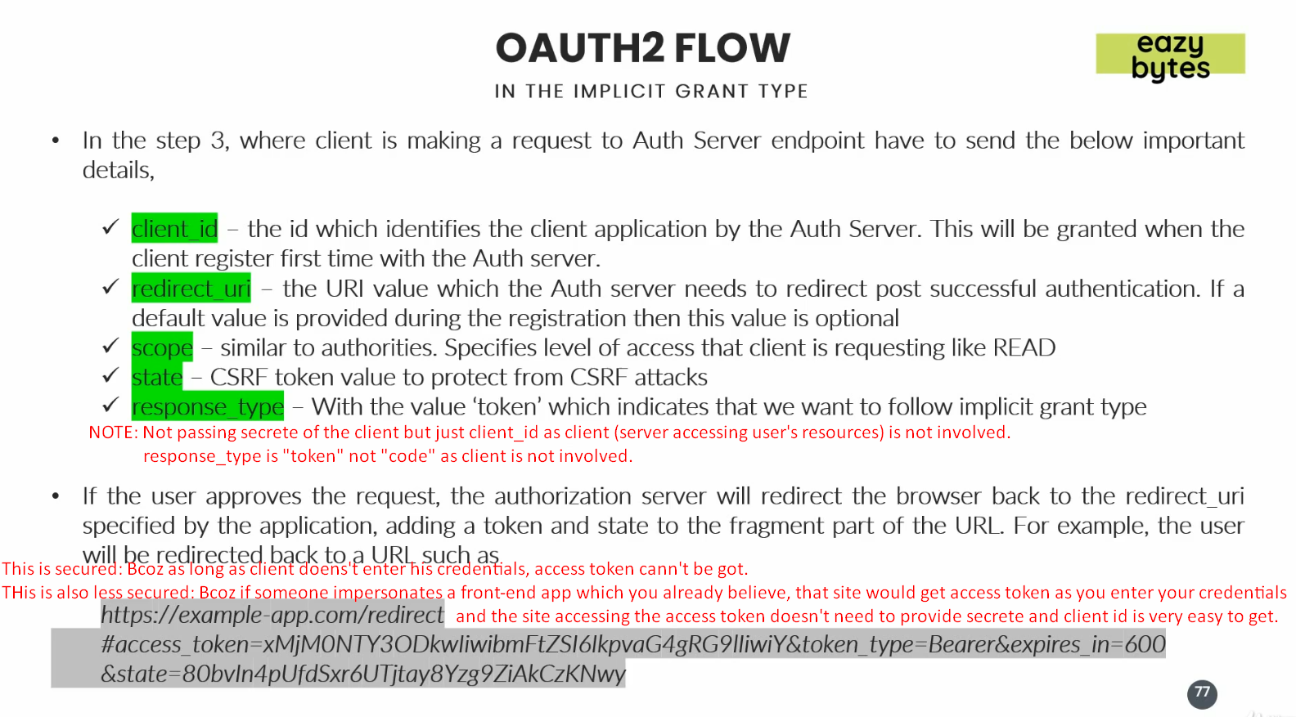
4. Where to use this flow?
   1. Where we don’t have backend app but the front-end in HTML, JS etc.